Detecting Fake News with Python

AIM: To build a model to accurately classify a piece of news as REAL or FAKE.

This advanced python project of detecting fake news deals with fake and real news. Using sklearn, we build a TfidfVectorizer on our dataset. Then, we initialize a PassiveAggressive Classifier and fit the model. In the end, the accuracy score and the confusion matrix tell us how well our model fares.

### Prerequisites

### 1. Install Jupyter Lab and then install a library scikit also called “sklearn” in python.

pip install numpy pandas sklearn

### Steps for detecting fake news with Python

1. Make necessary imports:

import numpy as np

import pandas as pd

import itertools

from sklearn.model_selection import train_test_split

from sklearn.feature_extraction.text import TfidfVectorizer

from sklearn.linear_model import PassiveAggressiveClassifier

from sklearn.metrics import accuracy_score, confusion_matrix

2. Now, let’s read the data into a DataFrame, and get the shape of the data and the first 5 records.

#Read the data

df=pd.read_csv(C:\\Users\\User\\Desktop\\news.csv')

#Get shape and head

df.shape

df.head()

3. Get the labels from the DataFrame:

#Get the labels

labels=df.label

labels.head()

4. Split the dataset into training and testing sets:

#Split the dataset

x_train,x_test,y_train,y_test=train_test_split(df['text'], labels, test_size=0.2, random_state=7)

5. Let’s initialize a TfidfVectorizer with stop words from the English language and a maximum document frequency of 0.7 (terms with a higher document frequency will be discarded). Stop words are the most common words in a language that are to be filtered out before processing the natural language data. And a TfidfVectorizer turns a collection of raw documents into a matrix of TF-IDF features.

Now, fit and transform the vectorizer on the train set, and transform the vectorizer on the test set:

#Initialize a TfidfVectorizer

tfidf_vectorizer=TfidfVectorizer(stop_words='english', max_df=0.7)

#Fit and transform train set, transform test set

tfidf_train=tfidf_vectorizer.fit_transform(x_train)

tfidf_test=tfidf_vectorizer.transform(x_test)

6. Next, we’ll initialize a PassiveAggressiveClassifier. This is. We’ll fit this on tfidf_train and y_train.

Then, we’ll predict on the test set from the TfidfVectorizer and calculate the accuracy with accuracy_score() from sklearn.metrics.

#Initialize a PassiveAggressiveClassifier

pac=PassiveAggressiveClassifier(max_iter=50)

pac.fit(tfidf_train,y_train)

# Predict on the test set and calculate accuracy

y_pred=pac.predict(tfidf_test)

score=accuracy_score(y_test,y_pred)

print(f'Accuracy: {round(score*100,2)}%')

7. We got an accuracy of 92.82% with this model. Finally, let’s print out a confusion matrix to gain insight into the number of false and true negatives and positives.

# Build confusion matrix

confusion_matrix(y_test,y_pred, labels=['FAKE','REAL'])

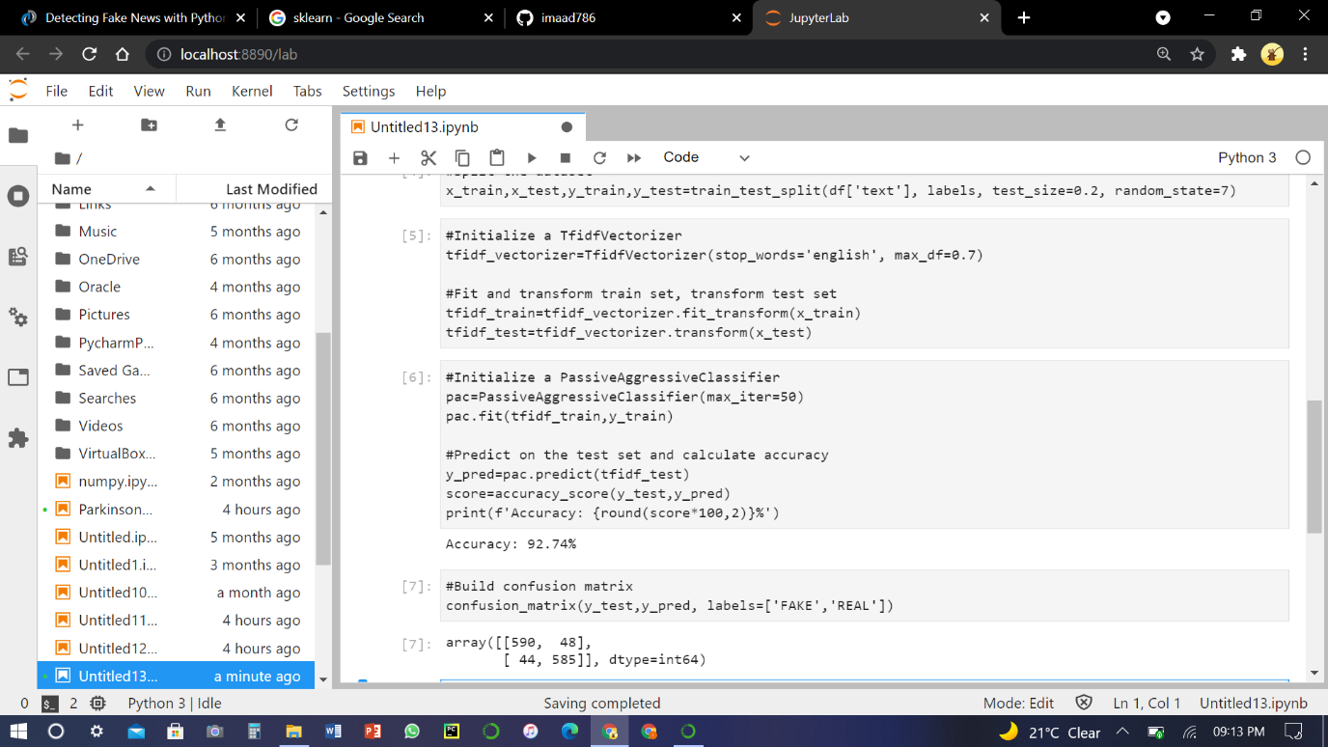

So with this model, we have 589 true positives, 587 true negatives, 42 false positives, and 49 false negatives with 92.74% accuracy.